Planning and Quality Control
Guide

Version 1 Date 31/03/2023

Contents
1. Definitions 3
2. Overview 3
3. Roles and Responsibilities 4
4. Preparing Inspection and Test Plans 4
4.1 General 5
4.2 Inspection and Testing Procedures 5
4.3 Lot and Lot Plan 5
4.4 Characteristics 8
4.5 Type and Frequency 8
4.6 Conformity 9
4.7 Acceptance Criteria 9
4.8 Hold and Witness Points 10
4.9 Checklists 10
4.10 Corrective Action Report 10
4.11 Records 11
4.12 Other Considerations 11
References 14
Document Control 14

- Definitions
Certifier | Building certifier/ building surveyor/ principal certifying authority, being the relevant authority providing building approvals, construction and occupancy certificates and the like.
Checklist | A logical list of items / activities being inspected for conformity as part of Surveillance Monitoring.
Corrective Action Report | CARs are a document used to record and track the resolution of non-conformances identified during inspections, tests, or daily operations. The purpose of CARs is to ensure that non-conformances are properly addressed and prevented from reoccurring.
Hold Point | A ‘hold’ point defines a point beyond which work may not proceed without the authorisation of a designated person, eg client representative, consultant, designated service provider or authority.
Inspection Test Plan | ITPs are a plan of When, What and How will conduct inspections and tests to ensure the work is meeting the projects specification, and necessary standards.
Inspection Test Report | ITRs are a report that provides evidence of checking conformity with acceptance criteria with traceability to the person(s) approving. All hold points, approvals, inspections, tests, and verifications for a specific element of works.
Lot/ Lot Plan | A specified work area, usually defined by location, where trade work or activity is being inspected / tested.
Non-Conformance | Any product or service which cannot achieve the specified or legislative requirements.
Quality | Describes the extent to which a set of characteristics fulfills the requirements.
Self-Inspection / Surveillance | Where the project team and or the subcontractor performing the work verifies the quality progressively – often with the aid of a checklist.
Technical Data Sheet | TDS is a document that provides detailed information about a product or material including its specification and characteristics. The purpose of a TDS is to provide accurate, comprehensive information about a product or material to facilitate its use.
Witness Point | A ‘witness’ point provides a third party (such as the client / certifier / consultant(s) / a regulatory authority) with the opportunity to witness the inspection or testing of an aspect of the work.

- Overview
This Guide is intended to assist in developing and implementing Inspection & Test Plans (ITPs) and associated Inspection Test Reports for construction work. Building standards are in the main described within the National Construction Code Series. Additionally, ISO 9001:2015, requires signatory organisations to:
Implement planned arrangements, at appropriate stages, to verify that the product and service requirements have been met.
The organisation shall retain documented information on the release of products and services. The documented information shall include:
- Evidence of conformity with the acceptance criteria;
- Traceability to the person (s) authorising the release.
There is also an expectation that clients, including end users / occupiers have, that buildings will be compliant with all relevant standards, and that the end product is fit for purpose.
To achieve this, an effective and efficient quality control process is required to ensure all obligations and expectations are being met.
Quality Planning identifies the items of materials and or work to be inspected or tested, by whom and at what stage or frequency, as well as Hold and Witness Points, references to relevant standards, acceptance criteria and the records to be maintained.
Quality controls, when properly implemented, helps ensure and verify that materials and work has been undertaken to the required standard and requirements, and that appropriate records are kept.
☞ The Inspection and Test Plan is the plan to systematically inspect and test the product progressively to identify and rectify deficiencies or nonconformities before they become part of the final construction product.

- Roles and Responsibilities
There are no set rules as to who should document the ITPs, checklists, and ITRs. However, input should be sought from a range of people with a good technical and practical knowledge of, and experience in, the activities involved. The use, understanding and acceptance of inspection checklists will generally be significantly improved if those required to participate in the process are involved in their preparation.
The project team is responsible for ensuring that all the required ITPs, checklists, and ITRs are prepared, including those covering work or processes to be carried out by subcontractors. While it is preferable that subcontractors have a quality control process for their own work, some may require the project team’s assistance to ensure project specific requirements are met.
☞ The Project Manager would typically be responsible for approving ITPs, checklists, ITRs and any subsequent amendments, prior to their implementation or submission for compliance / conformity certification.

- Preparing Inspection and Test Plans
As a general rule, the following steps are necessary in developing project specific ITPs, checklists and ITRs:
Step | Action
1 | Understand the contract documents, including the requirements of the building certifier/ consultants and prepare a list of any discrepancies, ambiguities, missing information, and standards of materials and/ or workmanship that are considered incomplete / inappropriate.
2 | Resolve any issues from Step 1 with the client / building certifier / consultants.
3 | Confirm the necessary Inspections, Test, Witness and Hold Points required by the client / certifier / consultants and the notification process to the appropriate person(s).
4 | Consider additional activities requiring an Inspection and Test Plan, i.e., other aspects not already identified in Step 3. including but not limited to; project specific quality risks, HSE requirements, lessons learned, manufacturers installation and warranty requirements, and where appropriate include in relevant ITP steps.
5 | Prepare each Quality Control activity to reflect the requirements as identified in above steps. Itemise the specific checklists which will be developed and implemented in the project specific Quality Management Plan.
6 | Decide how best to divide the whole of the project into work areas for control purposes and indicate these locations either on a schedule (with reference to grids and levels) or by marking up drawings, for reference on individual inspection records.
7 | Undertake a Quality Planning session with respective trades to agree activities and inform those directly involved with each of the checklists in their use.
8 | Carry out inspections and tests in accordance with the ITP, providing suitable notice to those required for Hold or Witness Points, and collate the results and records in appropriate ITR.
  - General
An Inspection and Test Plan is often part of or used in conjunction with the Quality Management Plan (QMP) and can be used to provide assurance to clients and end users that appropriate quality control activities will be undertaken, and the building will be fit for purpose and conforms with all requirements.
Generic ITPs may not cover the project specific requirements; therefore, ITPs need to be developed specific to each individual project.
It is important for project teams to review all project documents including specifications and relevant standards and construction codes to ensure appropriate ITPs are developed.
☞ The required standard is typically defined in the contract specification and in the relevant building standards. Instead of searching every time work is undertaken to determine conformity, an Inspection and Test Plan is developed that clearly communicates what will be tested, how and when for each type of activity.
  - Inspection and Testing Procedures
When it comes to undertaking inspections or tests, it is important to make sure that the results are accurate and consistent. In some cases, the methods used for the inspection or test are specified or obvious, but in other cases, you need to be specific about how the inspection or test should be done. A clear and well-described test procedure helps to achieve consistent and reliable results.
Important factors you might need to consider include:
- How you will reference work areas or lots
- The frequency of sampling
- The method of taking samples
- The method of conducting a test (including conditions)
- The qualifications of test personnel and equipment calibration, condition, and specification, and the method of documenting results
All of these factors help to ensure that the test is carried out in a consistent and reliable manner.
Doing so you can be confident that your inspection or test is being carried out in a way that is recognised and respected by experts in the field. This helps to ensure that the results you get from your inspection or test are accurate and reliable, which is essential for making informed decisions.
☞ Examples of standardised testing methods could include concrete and grout compressive strength tests undertaken by accredited third parties working to a standard.

☞ Examples of where inspection and test procedures may need to be identified and described to account for specific Technical Data Sheet (TDS) requirements include waterproof membrane coating thickness and adhesion testing.
  - Lot and Lot Plan
A lot refers to a distinct section of the whole work, usually defined by location, where any trade work or activity would be completed before it moves onto another area. Examples include a building, a floor, wall, a room, a length of pipeline between manholes and the like.
By breaking down a large project into smaller manageable areas, or lots, enables monitoring and tracking quality control activities more efficient and effective.
By having a clear lot plan in place, the project team can identify that each lot meets the required specifications and quality standards, helping to minimise the risk of defects, rework, and delays.
Consider how best to divide the project into Lots, or work areas for control purposes and specify these locations either in a schedule or by marking up on drawings. Use these identifiers for reference on individual inspection records.

Example Colour Coded Lot Plan
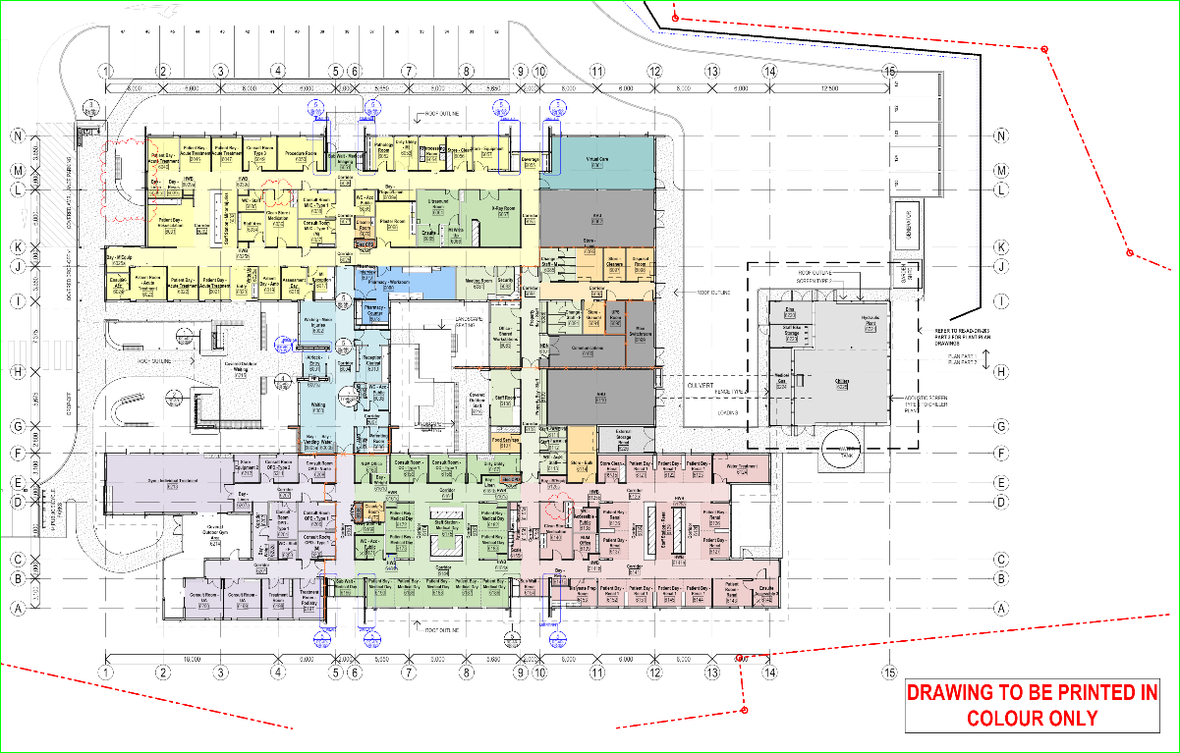

Example Schedule of Lots
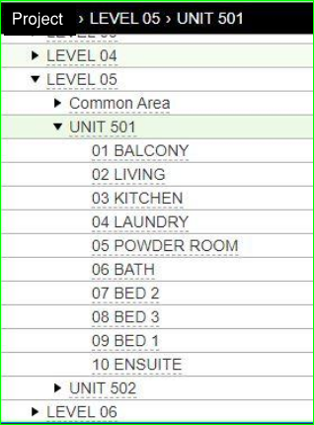

Example Lot Identification for Relevant Inspection Record
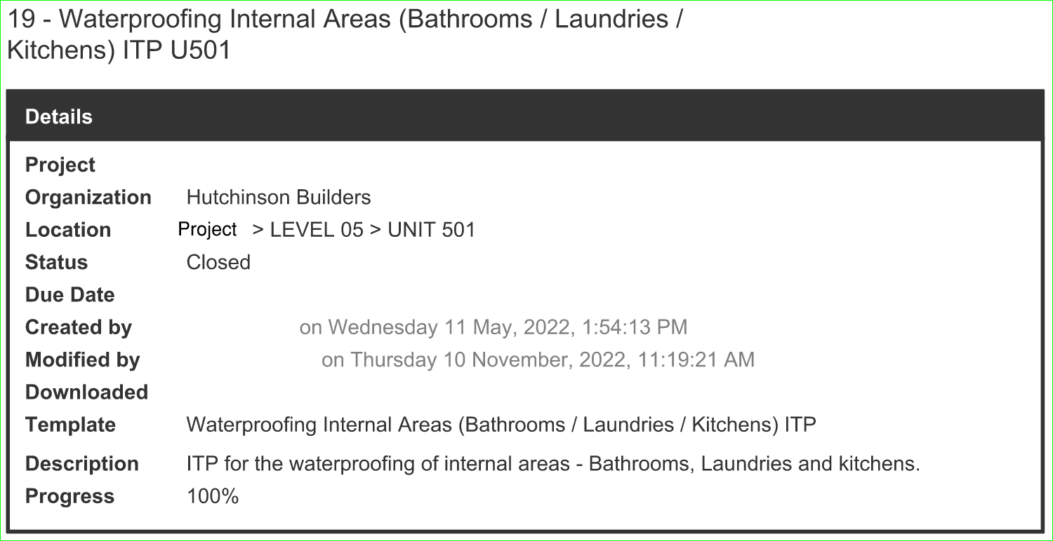

☞ Development of Lot Plans is critical for traceability in identifying relevant inspections and tests throughout construction and maintaining accurate records which limit ambiguities.
  - Characteristics
When compared with a safety management system, defining quality may seem to be a little harder to establish. Among the many definitions, it can be said that quality is:
- The extent to which a set of characteristics fulfills the requirements.
Using a risk-based, process approach, similar to how we would build safely, will allow us to manage quality through:
- Identifying the characteristics required; and
- By regularly checking that the requirements are being met
For a practical application of this we could use precast concrete elements, the characteristics to consider for managing quality could include but not limited to:
- Reinforcing and cast-in element requirements and position
- Concrete strength
- Concrete quality, colour, and level of surface finish
- Structural tolerance for installation and construction joint weather sealing
- Etc
Once we have identified all the relevant characteristics, we can then develop a suitable ITP and associated quality control activities to regularly check that the requirements are being met and inspection and test records are being maintained.
☞ Examples of characteristics include colour, size, texture, alignment, flatness, strength, capacity, performance, compatibility, durability, weather proofness, etc.
  - Type and Frequency
Inspecting and testing each element throughout construction is typically not effective nor practical. Inspections and tests are often best done in groups of several similar activities but prior to a major activity which will cover up the work.
The requirements of the contract documents may specify the type and frequency of specific inspection or tests, where this is not the case a realistic representative sampling of the work to suit the risks can be used. If non-conformities are identified during this process, then frequency of inspections and test would be increased along with a review of the process.
When determining the type and frequency of inspections and tests a risk-based thinking approach will consider, but not be limited to:
- Complexity of the detail of the work being undertaken
- Access for inspecting / testing
- Risk to health and safety or workers and members of the public
- Access if remedial work is required at a later date
- Consequential damage to other elements
- Resources

☞ The type, timing, and frequency (what, when and how often) of inspections and tests are best determined in conjunction with the characteristics to be verified.

☞ Some characteristics can only be considered after one stage but before another, such as the inspection of steel reinforcement arrangement in precast panel installed during panel manufacturing, would need to be checked prior to the pouring of concrete.
  - Conformity
Building standards are in the main described within the National Construction Code (NCC) Series and the relevant regulations as determined by the location and will be incorporated into project documentation through the project design phase by the relevant consultants.
However, there can be other inputs which need to be considered and implemented into the project specific ITP process. The contract specification will typically reference the applicable standards which may include reference to, but not limited to the following;
- Contract documents
- Drawings
- Regulatory requirements
- Australian/ New Zealand Standards (AS/NZS)
- International Standards (ISO)
- Manufacturers details
- Workshop drawings
- Samples and prototypes

☞ Where there are discrepancies or ambiguities between contract documents and applicable standards then these would need to be resolved with the client / building certifier / consultants before defining the required standard and acceptance criteria for ITPs.
  - Acceptance Criteria
Acceptance criteria are specific and measurable conditions that must be met for a product, service, or deliverable to be considered acceptable. Acceptance criteria are typically established during the planning stages of a project and are used to ensure that all parties involved have a clear understanding of what is expected.
The acceptance criteria can include requirements related to functionality, performance, usability, reliability, and other factors that are important to the stakeholders. For example, acceptance criteria for air conditioning unit covers located within 1000M of salt water may include an upgrade of powder coating to a minimum 80um.
Acceptance criteria will also be dependent on the characteristic being inspected or tested, typically this would include the results of the specified inspection or test, conformity with the relevant standard or specification. Where this is not evident or available then other means of acceptance criteria can be used, these include but are not limited to:
- Client / certifier / consultant approvals
- Approved workshop drawings
- Technical details
- Samples
- Prototype
- Manufacturers’ recommendations
Using a precast concrete element as a practical example, we can see how a combination of multiple acceptance criteria may be required.
Characteristic | Reference (Spec / Std / Dwg) | Acceptance Criteria | PASS | FAIL
Charcoal Coloured Concrete | Specification - Sample Panel | Sample Panel approval
40 Mpa Concrete | Engineers Detail Notes | Test as per AS1379
Class 1 Flatness | Specification | Inspected as per AS3610
Note This simplified example is not intended to consider all elements for an ITP.
Where an inspection or a test fails to meet the criteria then action is required to address the non-conformance. These actions include the immediate actions taken to deal with the issue as well as other actions to prevent recurrence.
☞ For further information see Corrective Action Report
  - Hold and Witness Points
A ‘hold’ point defines a point beyond which work may not proceed without the authorisation of a designated person, e.g., client representative, consultant, designated service provider or authority.
Hold points are a mandatory verification point beyond which works cannot progress without the authorisation of the assigned party to ensure:
- Safety of workers, public, or the environment before progressing
- The specified quality requirements have been met, including contract specification and or legislated requirements
Witness points are where the assigned party may take the opportunity to inspect the process, however subsequent work may proceed.
☞ If a non-conformance is identified during any quality control activity, it should prompt the creation a hold point to ensure all remedial actions have been completed.
  - Checklists
Checklists are useful reminders to the person doing the work of all the items to be addressed, they are also used to confirm all the items affecting quality have been considered, evaluated, and recorded during the process.
Checklists are not intended to replace qualitative inspections and tests; however, they do help those performing the works to:
- Be aware of the high risk or high probability issues
- Create a record of the inspection and what was inspected or checked
- Establish a consistent, structured approach
- Collect and record in-field data
☞ The fact that a checklist exists, and that their use and content have been verified, would give a client / certifier / consultant(s) / regulators confidence that all those doing the work are aware of all the important steps, characteristics, and the standards that should be complied with, and that conformity is being checked.
  - Corrective Action Report
On occasions the results of our inspections or tests may indicate deficiencies or non-conformities and we will need to take the required action to rectify them before they become part of our final product. Minor discrepancies and incomplete items are likely rectified during routine supervision and inspections.
On the other hand, when significant non-conformities are identified it may be appropriate to complete a Corrective Action Report (CAR).
Recording CARs allows us to review the non-conformance in the context of our overall Inspection and Test Plan. Some things to consider when completing a Corrective Action Report include:
- Define the issue
- Identify the significant cause
- What action is required to rectify the immediate non-conformance
- What actions are required to prevent reoccurrence
Whilst this may take time to record it will provide a record of the corrective action taken and that those changes meet the requirements. Constructions sites can be stressful with a lot of potential hazards, some important considerations when completing a Corrective Action Report include:
- There may be more than one cause of the non-conformance
- Those doing the work often understand the constraints and opportunities for improvement better than anyone
- The goal is to be more effective and efficient
- Respect for people is paramount

☞ Corrective action is responding to the non-conformance after it has been identified.

☞ Preventative action is the longer-term actions taken to prevent the non-conformance reoccurring in the future.
  - Records
Maintaining appropriate records assist in a number of ways, first it allows us to provide assurance to the relevant stakeholders that appropriate quality control activities have taken place, that the requirements have been met, and that the building is fit for purpose. It will also facilitate a lessons learnt culture through reviewing the results of inspection and testing activities.
Records can be maintained in a number of formats, including documents, photos, files, and the like, or you may get the added benefits of using a quality specific digital tool (Procore / Aconex or similar) to manage the required inspection and test and the subsequent records.
Whichever method is used it is important to note that the type, frequency, and acceptance criteria are set during the planning and documenting phase of ITP development. Consideration will also be required to the retention period and access to records may be required for the warranty period of up to 10 years and beyond.

☞ The records can be in various forms, and would include the surveillance checklists, test certificates, certificates of compliance / conformity, survey data, written approvals, corrective actions etc. Inspection and Test Plans would help define the records required.
  - Other Considerations
    - Safe Practices
Using a risk-based thinking process there are other considerations to make when preparing project specific ITPs. In addition to the physical characteristics, there would likely be the need to consider necessary checks and hold points for safe construction practices where these are also part of quality control.
This is particularly important when considering activities which rely on temporary engineering prior to completion of the final structure. Using the practical example of precast concrete elements, this could include checks, records, and hold points for:
- Calibration records for torque wrenches
- Correct installation of props and fixings
- Checklist for confirming temporary engineering is suitable until final structure is complete
- Engineers’ inspection and approval to remove temporary bracing elements etc.
Another example would be timber framing brackets and hangers. The correct selection, including design capacity and correct installation would be critical for compliance with the relevant NCC or Australian Standard. But it would also be imperative to inspect and ensure all connections had been completed to the required design before subsequent trades or activities progressed, this would typically be managed with a Hold Point.
☞ See the section on Hold and Witness Points for further details.
    - Lessons Learned
Lessons learned is the process of capturing and documenting the knowledge and insights gained from an experience, such as a project, program, or event. The goal of this process is to identify what worked well, what didn't, and what could be done differently in the future to improve outcomes. The lessons learned can then be used to inform decision making, improve processes, and minimise risks in future projects.
The benefits of lessons learned extend beyond individual projects or events. When implemented effectively, the lessons learned process can lead to continuous improvement and the development of best practices within an organisation. By capturing and sharing knowledge and insights, organizations can build on their successes and avoid repeating mistakes, leading to more efficient and effective decision making and improved outcomes.
Applying the principles of continuous improvement advocated by ISO 9001 we can use lessons learnt from the same or similar activities employed on previous projects to help us define the ITPs for current projects.
The best way to document lessons learned can vary depending on the context and the goals of the process. However, here are a few best practices that can be applied in most situations:
- Start documenting lessons learned early in the project and continue to do so throughout its duration. This will help ensure that all relevant information is captured and that the lessons learned process is as comprehensive as possible.
- Engage stakeholders in the lessons learned process, including project team members, subcontractors, and other relevant parties. This will help ensure that all perspectives are considered and that the lessons learned are as accurate and relevant as possible.
- Focus on documenting lessons that can be applied in the future, rather than just documenting problems and issues. This will help ensure that the lessons learned process is action-oriented and that the insights are useful for future decision making.
- Where possible document and track lessons learned. This can help ensure that the information is accessible and easily searchable, and that it can be easily shared with stakeholders.
- Make the lessons learned process a continuous one by regularly reviewing the information, updating it as needed, and using it to inform decision making in future projects and processes.

☞ The aim of Lessons Learned is to provide insight to help promote desired outcomes, whilst limiting the reoccurrence of undesirable outcomes.

    - Manufacturers Requirements
Manufacturer's requirements play a critical role in ensuring product quality. They provide a clear and concise definition of what the manufacturer expects including installation instructions, and inspection and testing requirements.
By including manufacturer’s requirements within an ITP will ensure that the product performs as expected in the conditions it was tested to. If these instructions are not followed there is no guarantee that the product will work as expected.

☞ Technical Data Sheets (TDS) are predominantly used by manufacturers to communicate the technical characteristics and requirements of an item or product and should be considered when developing specific ITP checklists, checks and inspections.

References

Systems
ISO 9001:2015 Quality Management

Document Control
Version | Date | Details | Authorised
1 | 31/03/2023 | DRAFT Guide Development | [Full Name]
Intellectual Property  Unless otherwise expressly agreed in writing, J Hutchinson Pty Ltd trading as Hutchies (ABN 52 009 778 330) (us / our / we) owns all material (including, but not limited to, designs, methodologies, programs, value management, policies, procedures, and other intellectual property) created by us and our company members, agents, consultants and subcontractors in the development of this document and contained within this document or associated attachments (“Material”).  Protected by Copyright  Further, this Material is protected by copyright which is and will remain at all times owned by us, or our partners (where we have included their content in our Material), and all rights are strictly reserved. This Material must not be copied in whole or in part without our prior written approval.  For Information Only  This Material is provided to the recipient for information only and is non-binding. You must not rely on this Material for your own purposes and we disclaim any responsibility or liability to you arising from or in connection with your use of this document for unauthorised purposes. We reserve the right to withdraw or void any or all of its contents at any time without notice to the recipient. If a validity period or expiration date is specified within, it is automatically void after this period unless we agree to an extension in writing. | No Liability  We disclaim any responsibility or liability to you arising from or in connection with your use of this Material (including documents within the Material authored by third parties) in line with these conditions.  Confidentiality  The information, including any intellectual property, contained within this Material is (to the extent permitted by law) confidential and proprietary to us. It may only be used by the person to whom it is provided for the stated purpose for which it is provided and must not be imparted to any third party without our prior written approval. Without limiting the paragraph above, any recipient of the Material agrees to keep confidential, and to ensure its employees, agents and subcontractors keep confidential, all information contained herein which is confidential and not to disclose that confidential information without our prior written approval.  Third Party Opinions  Where the Material provided includes documents authored by third parties, any opinions contained in those documents may not represent our views and we disclaim any responsibility or liability to you arising from or in connection with your use of this document for unauthorised purposes.  Legal Rights  We reserve all our legal rights and remedies in relation to any infringement of our rights in respect of this document and information contained within it.  More Information  For Hutchies’ full terms, please visit hutchies.com.au/disclaimer

This guide has been developed to provide tools and resources for the broader construction industry on topics to support continual improvement in safety and quality in the industry.

