Viewpoint Guide

Updating the Budget Meeting Report
- Open PM Projects
- Click on the Budget Meeting Adj tab
- Edit/Add the entry for the current month (Do not forward date an entry)
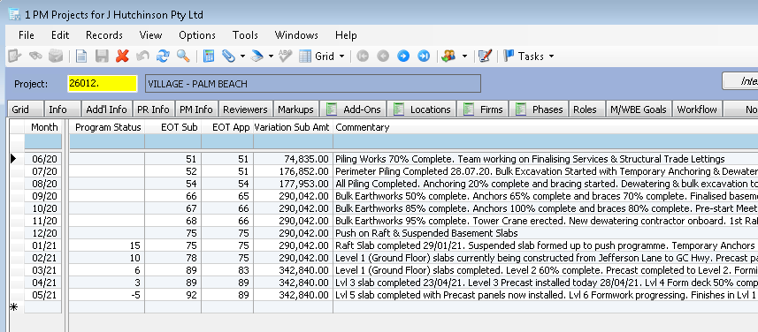
- Run the Monthly Budget Meeting report to confirm changes.

Important Notes
At the start of every month, the prior months “Budget Meeting Adj” record will be copied into the new month ready for updating
  - This process will copy the prior months EOT Sub, EOT App, Variation Sub Amt. Commentary will be left blank ready for entry.
  - Do not create a new record in a future month. Wait until the record is created automatically for your project. Any future month entries will be deleted.

Field Mapping
Budget Meeting Adjustment Form | Budget Meeting Sheet
EOT Sub | EXT Time Claim Sub
EOT App | Ext Time Claims App
Variation Sub Amt | Variation Claim Sub
Commentary | Comments
Program Status | Program Status

Other Budget Meeting Sheet updates
For any updates on completion dates, please email james.taylor@hutchinsonbuilders.com.au
For all other help, please email viewpointsupportgroup@hutchinsonbuilders.com.au

